Basis | Maslow’s Need Hierarchy Theory | Alderfer’s ERG Theory
Hierarchy of needs | Maslow’s Need Hierarchy Theory has 5 different levels of need. | Alderfer’s ERG Theory has only 3 levels of need.
Motivation Cause | In Maslow’s Need Hierarchy Theory at one point of time only one level of need can cause motivation. | In Alderfer’s ERG Theory more than one levels of needs can cause motivation at the same time.
Frustration element | In Maslow’s Need Hierarchy Theory individual will remain in the same level of needs until achieving satisfaction. | In Alderfer’s ERG Theory if needs remain unsatisfied, the individual become frustrated and regress to lower level needs.
Movement | Maslow’s saw people moving steady up the hierarchy of needs | Alderfer saw people moving up and down the hierarchy of needs from time to time and from situation to situation.
Figure | 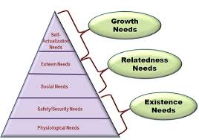 | 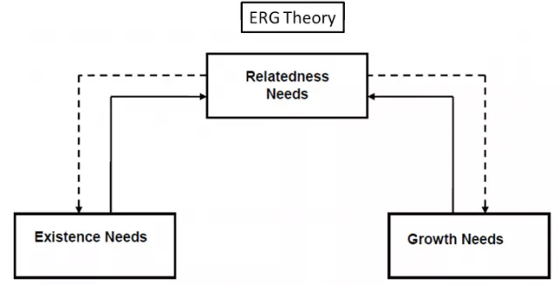
Universality of Order | Maslow’s Need Hierarchy asserts that the order of needs is universal. | Alderfer’s assert that the order of needs is different per individual.

